Select \* from dept

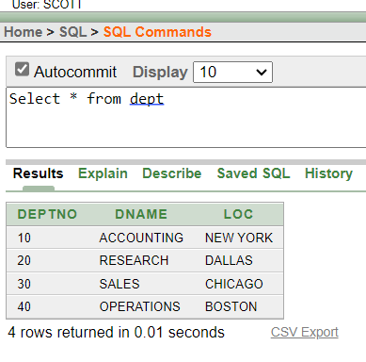

Select deptno,loc from dept

select ename, sal, sal+300 from emp;

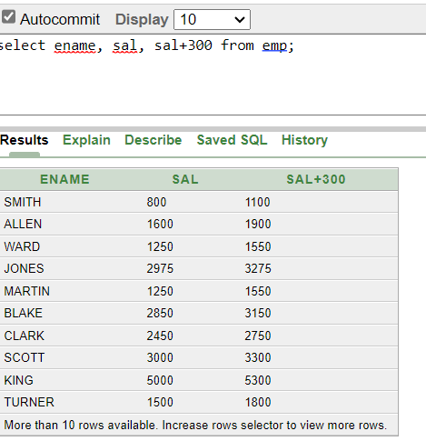

select ename, sal, 12\*sal+100 from emp;

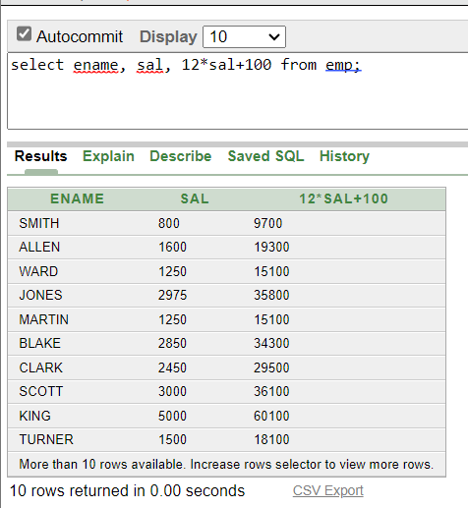

select ename, sal, 12\*(sal+100) from emp;

select ename, job, comm from emp;

select ename, 12\*sal+comm from emp;

select ename As name, sal salary from emp;

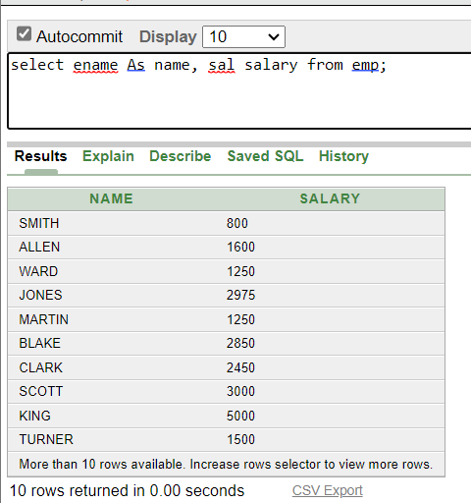

select ename As "Name", sal\*12 "Annual salary" from emp;

select ename||job As "Employee" from emp;

select deptno from emp;

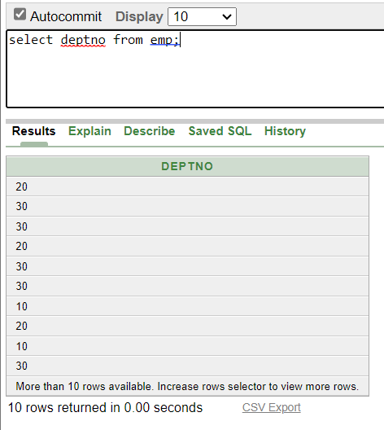

select Distinct deptno from emp;

describe dept;

